**PIZZA’s SALES SQL QUERIES**

1. **KIP’s**
2. **TOTAL REVENUE**

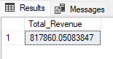**QUERY:** SELECT SUM(total_price) AS Total_Revenue FROM pizza_sales;

**OUTPUT:**

1. **AVERAGE ORDER VALUE**

**QUERY:** SELECT SUM(total_price) / COUNT(DISTINCT order_id) AS Average_Order_Value FROM pizza_sales;

**OUTPUT:** 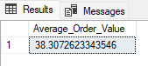

1. **TOTAL PIZZAS SOLD**

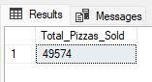**QUERY:** SELECT SUM(quantity) AS Total_Pizzas_Sold FROM pizza_sales;

**OUTPUT:**

1. **TOTAL ORDERS**

**QUERY:** SELECT COUNT(DISTINCT order_id) AS Total_Order FROM pizza_sales;

**OUTPUT:** 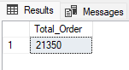

1. **AVERAGE PIZZAS PER ORDER**

**QUERY:** SELECT CAST(CAST(SUM(quantity) AS DECIMAL(10, 2))/CAST(COUNT(DISTINCT order_id) AS DECIMAL(10, 2)) AS DECIMAL(10, 2)) AS AVERAGE_PIZZAS_PER_ORDER FROM pizza_sales;

**OUTPUT:** 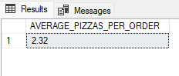

1. **DAILY TREND FOR TOTAL ORDER**

**QUERY:** SELECT DATENAME(DW, order_date) AS ORDER_DAY, COUNT(DISTINCT order_id) AS TOTAL_ORDERS from pizza_sales GROUP BY DATENAME(DW, order_date);

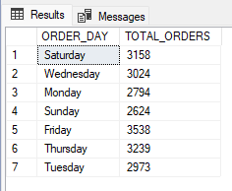**OUTPUT:**

1. **MONTHLY TREND FOR ORDERS**

**QUERY:** SELECT DATENAME(MONTH, order_date) AS ORDER_MONTH, COUNT(DISTINCT order_id) AS TOTAL_ORDER from pizza_sales GROUP BY DATENAME(MONTH, order_date);

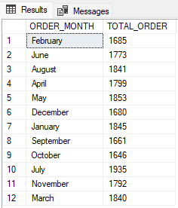**OUTPUT:**

1. **PERCENTAGE OF SALES BY PIZZA CATEGORY**

**QUERY:** SELECT pizza_category, CAST(SUM(total_price) AS DECIMAL(10, 2)) AS TOTAL_REVENUE,

CAST(SUM(total_price) * 100 / (SELECT SUM(total_price) from pizza_sales) AS DECIMAL(10, 2)) AS PCT from pizza_sales GROUP BY pizza_category;

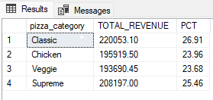**OUTPUT:**

1. **PERCENTAGE OF SALES BY PIZZA SIZE**

**QUERY:** SELECT pizza_size, CAST(SUM(total_price) AS DECIMAL(10, 2)) AS TOTAL_REVENUE, CAST(SUM(total_price) * 100 / (SELECT SUM(total_price) from pizza_sales) AS DECIMAL(10, 2)) AS PCT from pizza_sales GROUP BY pizza_size ORDER BY pizza_size;

**OUTPUT:** 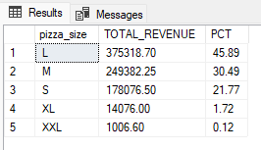

1. **TOTAL SALES BY PIZZA CATEGORY**

**QUERY:** SELECT pizza_category, SUM(quantity) AS SALES_BY_CATEGORY FROM pizza_sales GROUP BY pizza_category ORDER BY SALES_BY_CATEGORY DESC;

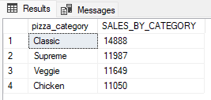**OUTPUT:**

1. **TOP 5 PIZZAS BY REVENUE**

**QUERY:** SELECT TOP 5 pizza_name, CAST(SUM(total_price) AS DECIMAL(10, 2)) AS TOP_5_SALES FROM pizza_sales GROUP BY pizza_name ORDER BY TOP_5_SALES DESC;

**OUTPUT:** 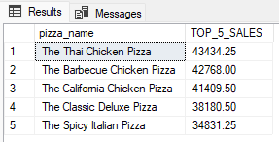

1. **BOTTOM 5 PIZZAS BY REVENUE**

**QUERY:** SELECT TOP 5 pizza_name, CAST(SUM(total_price) AS DECIMAL(10, 2)) AS BOTTOM_5_SALES FROM pizza_sales GROUP BY pizza_name ORDER BY BOTTOM_5_SALES ASC;

**OUTPUT:** 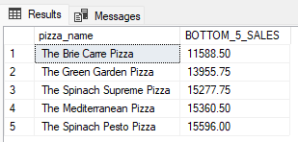

1. **TOP 5 PIZZAS BY QUANTITY**

**QUERY:** SELECT TOP 5 pizza_name, SUM(quantity) AS TOP_5_BY_QUANTITY FROM pizza_sales GROUP BY pizza_name ORDER BY TOP_5_BY_QUANTITY DESC;

**OUTPUT:** 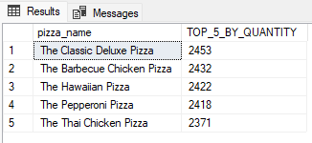

1. **BOTTOM 5 PIZZAS BY QUANTITY**

**QUERY:** SELECT TOP 5 pizza_name, SUM(quantity) AS TOP_5_BY_QUANTITY FROM pizza_sales GROUP BY pizza_name ORDER BY TOP_5_BY_QUANTITY ASC;

**OUTPUT:** 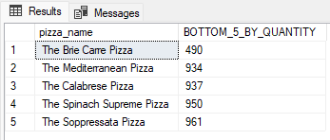

1. **TOP 5 PIZZAS BY TOTAL ORDER**

**QUERY:** SELECT TOP 5 pizza_name, COUNT(DISTINCT order_id) AS TOP_5_BY_ORDER FROM pizza_sales GROUP BY pizza_name ORDER BY TOP_5_BY_ORDER DESC;

**OUTPUT:** 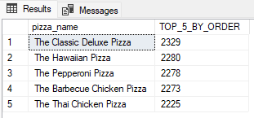

1. **BOTTOM 5 PIZZAS BY TOTAL ORDER**

**QUERY:** SELECT TOP 5 pizza_name, COUNT(DISTINCT order_id) AS BOTTOM_5_BY_ORDER FROM pizza_sales GROUP BY pizza_name ORDER BY BOTTOM_5_BY_ORDER ASC

**OUTPUT:** 